**EX NO:11D**

**Date:28.10.24**

**REMOTE PROCEDURE CALL FOR SORTING AN ARRAY -XMLRPC**

**AIM:**

To Implement an XML RPC code for sorting array

Algorithm:

**Algorithm**

**Server Program**

1. **Import Required Library**: Import the xmlrpc.server library, which provides functionalities for setting up an XML-RPC server.
2. **Define sort_array Function**:
   1. Define a function called sort_array that takes a list (arr) as input. ○ Inside this function, return the sorted version of arr.
3. **Set Up Server**:
   1. Create an instance of SimpleXMLRPCServer, specifying localhost as the host and 8000 as the port.

○ Print a message indicating the server is running.

1. **Register Function**:
   1. Register the sort_array function with the XML-RPC server under the name "sort_array". This makes it available for remote calls.
2. **Run the Server**:
   1. Call server.serve_forever() to start the server and keep it running indefinitely, waiting for client requests.

**Client Program**

1. **Import Required Library**: Import the xmlrpc.client library to enable communication with the XML-RPC server.
2. **Connect to Server**:
   1. Create a ServerProxy object to connect to the server running on http://localhost:8000.
3. **Prepare Input Array**:
   1. Define an array arr with some integer values that will be sent to the server for sorting.
4. **Call sort_array Method**:
   1. Use the server.sort_array() function to send arr to the server for sorting.

○ Store the result (sorted array) in a variable sorted_arr.

1. **Display Results**:
   1. Print the original arr and the sorted_arr to verify the sorting operation was successful.

**Program:**

**SERVER PROGRAM:** import xmlrpc.server

*# Function to sort the array* def sort_array(arr): return sorted(arr)

*# Setting up the server* with xmlrpc.server.SimpleXMLRPCServer(('localhost', 8000)) as server:

print("Server is running...")

*# Registering the sort_array function as an XML-RPC method*

server.register_function(sort_array, 'sort_array') server.serve_forever()

**CLIENT PROGRAM:**

import xmlrpc.client

*# Connect to the server* server = xmlrpc.client.ServerProxy('http://localhost:8000')

*# Input array to be sorted* arr = [12, 4, 5, 3, 7, 2]

*# Calling the sort_array method on the server* sorted_arr = server.sort_array(arr)

*# Displaying the result* print("Original Array:", arr) print("Sorted Array:", sorted_arr)

**Output**

**SERVER OUTPUT**



**CLIENT OUTPUT**

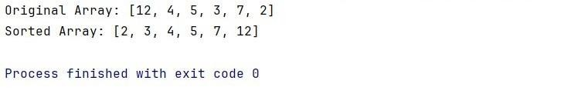

**RESULT:**

Procedure call for sorting an array - XMLRPC remoted.